22.5 MW Bhilangana Hydro Power Project (BHPP)
Swasti Power Engineering Limited (SPEL) is developing the 22.5 MW hydro electric power project on the Bhilangana River. The project is a run-of-the river hydroelectric project, which envisages harnessing the perennial waters of Bhilangana River – a major tributary of the River Bhagirathi. The purpose of the project is to generate environmentally clean electricity and contribute towards meeting the acute regional power requirements. Except for some small flourmills which harness the running water to run the mills, the water potential of the river remains un-utilized. The project will supply electricity to Northern grid.
Contribution of the project activity to Sustainable Development
As per Government of India the following indicators for sustainable development have been stipulated in the interim approval guidelines for CDM projects :
- Social well being
- Economic well being
- Environmental well being
- Technological well being
The performance of the Bhilangana hydro power project across the above indicators is as follows:

Social well being:
The project activity would result in the employment of the local people during the construction and operation phases. The project activity being a run-of the river project does not result in any displacement of local people.
The irrigation facilities tend to dry up in the lean discharge months because of the lack of adequate intake diversion structures. Provision of sacrifice discharge to the tune of 0.25 m3/s has been made in the design of the scheme to guarantee a perennial supply of water needed for the irrigation channel downstream.

Economic well being:
The northern grid is facing shortage of electrical power and thereby stunting the economic growth. The project activity will be a move towards bridging the supply and demand gap. During construction and operation of the project, employment would be generated for the local population.

Environmental well being:
The project will result in generation of clean and green power without any GHG emissions. Also, since it is a run-of-the river project there is no storage and hence no submergence. Though no deforestation is required in the project activity still budget for afforestation has been provided. Fish ladder has been provided for free movement of fish on either side of the diversion weir.

Technological well being:
Highly efficient turbines and generators are being used in the project and the power transmission will be at high voltage to ensure low losses.

This demonstrates that the project activity contributes positively towards sustainable development.

Detail of physical location, including information allowing the unique identification of this project activity :
The project activity is located a few kilometres North of Ghansali township (Longitude 78o34’30”, Latitude 30o25’41”). The project site is about 45 kilometers from the origin of River Bhilangana. The topography of the area is rugged. The project area is within the main Himalayan belt, a tectona-litho stratigraphic belt, with the granite-gneiss of the Central Himalayan Crystallines in the northern part, and the quartzites with associated metabasics of the Garhwal group in the southern part.The access road to the project site is the Tehri-Ghansali-Koti Road.
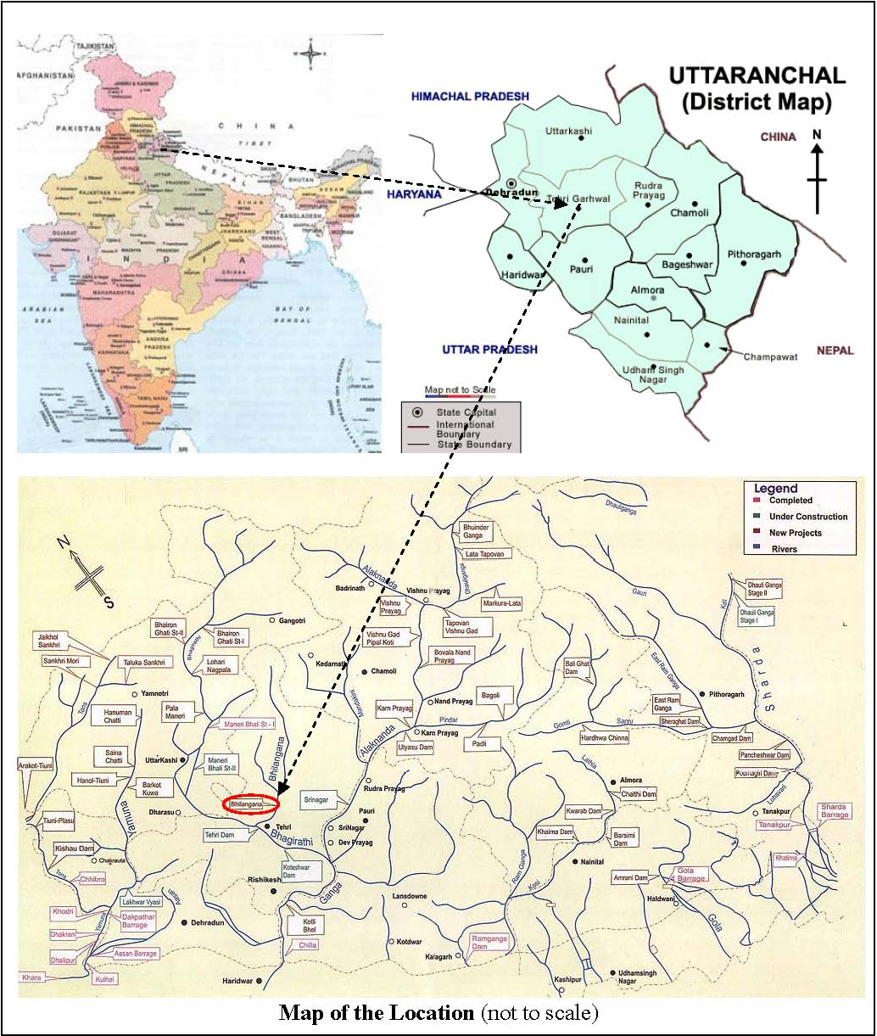

The scheme comprises of Boulder Weir 44 m long and 5 m high with an intake structure to divert and regulate the waters into the 594.17 m long horse shoe shaped interconnecting tunnel, which leads the water into a 117 m long, 12.6 m wide and 16 m high D-shaped underground desilting tank. The silt free water is led to a surge shaft via a 4.0 m dia horse shoe shaped Head Race Tunnel (HRT), which is in two parts namely HRT-1 and HRT-2 with an aqueduct in between the two tunnels for crossing of the Phelenda Nala. HRT-2 terminates into the circular surge shaft of 12 m dia and 39 m high. Following the surge shaft at the exit portal emerges a single steel penstock of 3.25 m dia and 370 m long, which trifurcates into three branches of 1875 m dia just before entering the powerhouse. The powerhouse is a surface type power house, which houses three Francis type turbo generators – each of 7.5 MW capacity. The tail water emerging out from the three machines is led back to Bhilangana River via a short tailrace channel.
The project activity would be incorporating the latest / state-of-the-art technologies available in the field of hydro electric power generation as given by the Central Electricity Authority of India2 i.e.,:

- Use of digital turbine governors for speed regulation of hydro turbines
- Computerised Control System for control of generating unit, station & units, auxiliaries, H. V. Switchgear, Intake Gates etc.
- Gas Insulated Switchgear as it involves minimum maintenance and much lesser space to install.

No import of technology is involved in the project activity.
As the project is a run-of-the river hydro electric project, there are no GHG emissions from the project. The BHPP will be supplying power to the Northern grid which comprises mainly of coal (61.6%) and gas (11.5%) based power plants (please refer Annex 3). It displaces conventional energy equivalent of 1219.56 GWh thereby resulting in total emission reduction of 1,093,040 tons of CO2e over ten years crediting period. No appreciable transmission and distribution losses will occur since the power from the project site will be evacuated at a high voltage of 220 kV for a relatively short distance. In the absence of the project activity, equivalent electrical load would have been taken up by the grid mix, which is mainly dominated by fossil fuel based power plants leading to GHG emissions. Thus the BHPP would help in reducing the anthropogenic GHG emissions as per the combined margin carbon intensity of the Northern Grid.

