16th Symposium on Earthquake Engineering
Paper Formatting Instructions
(Title of paper, Bold, Arial, 16 point)

M. L. Sharma^{1*}, Y. Singh² and B. K. Maheshwari³
(Initials followed by Surname, Bold, Times New Roman, 12 point)

¹Professor, Dept. of Earthquake Engineering, IIT Roorkee, mukutfeq@iitr.ac.in
²Professor, Dept. of Earthquake Engineering, IIT Roorkee, yogenfeq@iitr.ac.in
³Professor, Dept. of Earthquake Engineering, IIT Roorkee, bkmahfeq@iitr.ac.in
(Designation, affiliation and email. Indicate corresponding author with an astrix (*), for multiple authors use separate lines, Times New Roman, 10 point)
Abstract (All headings, Bold, 14 point, Times New Roman, 2 line spacing before and 1 line spacing after the heading)
This article presents detailed instructions for the preparation of full length paper for the 16SEE-2018 at IIT Roorkee. Use ‘Times New Roman (TNR)” font consistently until or unless mentioned otherwise. Body text shall be of 12 pt normal, justified and single spacing. Please avoid reporting of routine trends, routine characterization as the main accomplishment of the study. The novelty and its impact on Earthquake Engineering knowledge database need to be brought forth.
The paper shall be provided with the motivation for the work and objective of the paper. It shall discuss the methodology adopted in the study for achieving the objective. Details about the various stages in the methodology shall be provided. Important outcomes of the study must be presented. Main conclusions highlighting the novelty of the work have to be mentioned. Abstract should illustrate the work and should have conclusions drawn out of the work described in the paper. Remaining body of the paper must include detailed description of entire methodology used in study with proper findings from the work, following discussions and conclusions.
Introduction
An author’s central obligation is to present a concise account of his or her research work, or project accompanied by an objective discussion of its significance. Submitted papers should contain detail and reference to public sources of information, so that the author’s peers are able to repeat the work or otherwise verify its accuracy.
16SEE-2018 requires that conference proceedings papers be original, unpublished work. Dual publication (publishing the same paper in multiple places without permission of the original publisher and agreement by the subsequent publisher) is a professional ethics violation and problem of plagarism. It is inappropriate to submit abstracts or papers with an obvious commercial intent. It is also inappropriate to criticize another paper with personal attacks on the author(s).
All the accepted papers will be published in conference proceedings and presented during 16SEE-2018. It is must that one of the authors registers for the conference.
Manuscript Formatting
A proceeding paper consists of a title; an author byline and affiliation(s); an abstract; introduction; the text with optional tables, figures, equations and formulae; conclusion; and references. Acknowledgments, appendixes, and notations are optional. Manuscript shall be written using MSWord in .doc or .docx format. 6 point spacing should be given between the two paragraphs.
Paper Length (Sub-headings, Bold, 12 point Times New Roman, 12 point spacing before and 6 point spacing after the heading)
The length of the paper should be kept between 6 to 10 pages. Total paper length includes all text, graphics, references, and appendixes. Any paper, more than 10 pages will be returned to authors.
Point size and Font
Use 12 point type for text, captions. For type within figures or tables, the 12 point size is preferred. It is recommended to select text font as Times New Roman. Maintain the size and font throughout the paper as given in the instructions.
Headers and Footers
Do not put any additional information in the header other than already provided in the template. The only acceptable content in the footer is a single page number at the center on the bottom.
Layout
All text must be single-spaced. Page design should be consistent throughout the paper and use A4 size. Margins should be 1 inch (25.4 mm) on all sides, and all elements (text, figures, tables, captions) must fit within those margins.
Figures and Tables
All graphics (photos, line art, charts and tables) must be included electronically (embedded) within the document and fit within the margin settings. Illustrations should be numbered consecutively as they are presented (Figure 1, Figure 2 etc., and Table 1, Table 2 etc.). Each figure and table should be mentioned in the text.
Captions and Legends
A descriptive caption, including in figure number, should be placed directly below the illustration (see Figure 1). A descriptive caption, including table number, should be placed immediately above the table (see Table 1). If any figure or table is taken from literature with due permission its source shall be cited and listed in the references. One clear line spacing should be kept between text and start (and end) of the figures and tables (including captions)
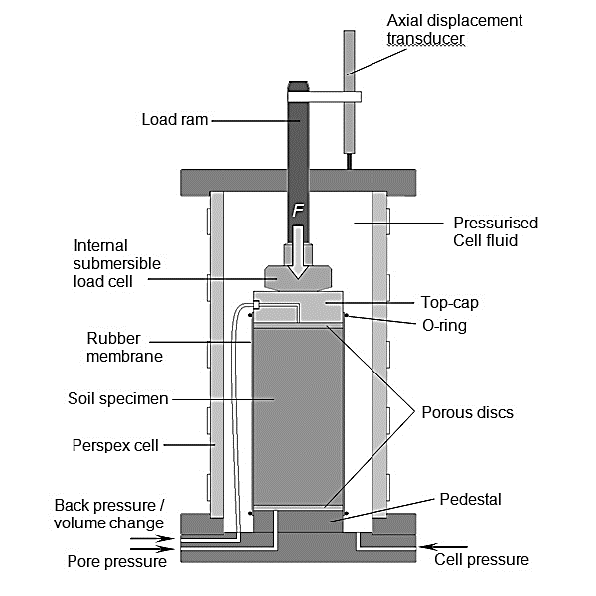
Figure 1. General Set-up of a Soil Specimen inside Triaxial Cell

Figure 2. Modulus Reduction Curves: Literature and Solani Riverbed Site
(After Kirar and Maheshwari, 2017)

Style
All labels of figures should be clearly visible and aspect ratio should also be maintained. Table should be compact avoiding unnecessary margins. Content of each shell should be in one line as far as possible.

Table 1. Typical Modelling Parameters for Beams and Columns for Uniformly In-filled Frames (After Pisode et al. 2017)
Design  Level | No. of storeys | Member  Description | Concrete compressive strength (MPa) | Rebar strength  (MPa) | Member sizes  (mm) | Axial force ratio | θ_{p}  (Rad.) | θ_{pc}  (Rad.)
Without SCWB | 4 | Beam | 30 | 500 | 300 x 350 | 0.00 | 0.025 | 0.025
Without SCWB | 4 | Column | 30 | 500 | 300 x 350 | 0.23 | 0.027 | 0.007
Without SCWB | 8 | Beam | 30 | 500 | 300 x 400 | 0.00 | 0.025 | 0.025
Without SCWB | 8 | Column | 30 | 500 | 400 x 400 | 0.52 | 0.027 | 0.007
With SCWB | 4 | Beam | 30 | 500 | 250 x 350 | 0.00 | 0.025 | 0.025
With SCWB | 4 | Column | 30 | 500 | 350 x 350 | 0.20 | 0.026 | 0.007
With SCWB | 8 | Beam | 30 | 500 | 300 x 400 | 0.00 | 0.025 | 0.025
With SCWB | 8 | Column | 30 | 500 | 400 x 400 | 0.52 | 0.015 | 0.003

Mathematics
Mathematical equations should not be written using text but using insert equation option. All equations need to be numbered. Each equation should be mentioned in the text or “called out” before it appears.
$m\ddot{x }+c\dot{x}+kx=p(t)$ (1)
System of Units
The use of SI units is encouraged. For more information about SI units, visit the Web sites of the U.S. Metric Association (USMA), Inc. or the National Institute of Standards and Technology (NIST).
References
All factual material that is not original must be accompanied by a reference to its source. 16SEE-2018 prefers the author-date system of referencing. The author-date system has two parts, the text citation and the reference list.
- The text citation appears where the material to be cited is presented and it refers readers to a source in the reference list by the author's last name and year of publication. If there are more than 2 authors, use ‘et al.’ after the last name of first author, e.g. Pisode et al. (2017). In case of only 2 authors, use their last names and year of publication, e.g. Kirar and Maheshwari (2017). If the author and date appear in parentheses; a comma should be placed between them e.g. (Kirar and Maheshwari, 2017).
- The reference list appears at the end of the paper. It should be single-spaced and list each reference alphabetically by the last name of the first author. When two or more references by the same author are listed, year of publication is taken into account, and the earliest work is listed first. Follow, ISET journal style for writing references. Some sample references are listed at the end of this paper.
All the cited sources shall be listed in the references and vice-versa.
Conclusions
Content of this section should include major contributions or findings from your work. 16SEE-2018 thanks you for your efforts and looks forward to providing a record of this conference that will be useful to you and your colleagues for many years to come.
References
- Author’s last name, followed by first name. (Year). “Title”. Name of journal/proceeding, Vol., Issue, pp. 12 point TNR.
- Agarwal, P., Thakkar, S.K. and Dubey, R.N. (2002). “Seismic Performance of Reinforced Concrete Buildings During Bhuj Earthquake of January 26, 2001”, ISET Journal of Earthquake Technology, Vol. 39, No. 3, pp. 195-217.
- Govindaraju, L. (2005). “Liquefaction and Dynamic Properties of Sandy Soils”. Ph.D. thesis, Dept. of Civil Engineering, Indian Institute of Science, Bangalore, India.
- IS 1893-Part 1 (2016). "Criteria for Earthquake Resistant Design of Structures: General Provisions and Buildings". Bureau of Indian Standards, New Delhi.
- Kirar B. and Maheshwari B.K. (2017). “Dynamic Properties of Soils at Large Strains in Roorkee Region using Field and Laboratory Tests”. Indian Geotechnical Journal. doi: 10.1007/s40098-017-0258-2.
- Kramer S.L. (1996), “Geotechnical Earthquake Engineering”. Pearson Education Pvt. Ltd., Singapore.
- Maheshwari, B. K., Kaynia, A. M., and Paul, D. K. (2008). “Liquefaction Susceptibility of Soils in Himalayan Region”. Proceeding of 14th World Conference on Earthquake Engineering, Beijing, China.
- Pisode M., Surana M., Haldar P and Singh Y. (2017). "Comparative Assessment of Seismic Fragility of RC Frame Buildings designed for Older and Revised indian Standards". ISET Journal of Earthquake Technology, Vol. 54, No. 1, pp. 17-29.
- Syed N.M. and Maheshwari B.K. (2017). "Nonlinear SSI Analysis in Time Domain using coupled FEM-SBFEM for a soil-pile system". Géotechnique, Vol. 67, No. 7, pp. 572–580.

